THE OVERALL FLOWCHART OF THE SOFTWARE:

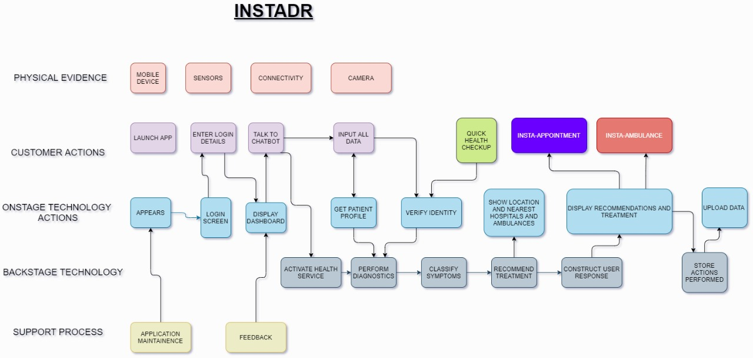

THANKING YOU…

TEAM: Runtime Terror